SIMATS ENGINEERING
ASSESSMENT TOOL 1: Experiments

COURSE NAME: Cloud Computing and COURSE CODE: CSA1596
Big Data Analytics

COURSE OUTCOME COVERED
CO3: Implement cloud-based solutions using cloud storage, web APIs, and platform services for real-world applications. (BL3)
Assessment Tool Weightage: 40%

Dave's Taxonomy: Precision (Level 3) Total Marks: 40
Question Count: 4

Duration : 60 Minutes

Code of Conduct
I Krishna Chaitanya / 192372241 certify that this submission is my original work and that I have adhered to the guidelines specified for this assessment.
I understand that any violation of academic integrity rules will result in disciplinary action.
Signature of the student:

Experiments Rubric
Criteria | Weightage | Level 4 -  Exemplary | Level 3 -  Proficient | Level 2 -  Developing | Level 1 -  Beginning
Experimental Design | 25% | Design is systematic and technically strong | Mostly correct design | Basic design with gaps | Poorly designed activity
Use of Tools / Platforms | 20% | Appropriate and effective use of cloud tools | Good tool usage with minor issues | Limited tool usage | Incorrect or missing tool usage
Application of Concepts | 20% | Concepts are applied accurately to practical tasks | Mostly accurate application | Partial application | Weak application
Analysis and Output | 20% | Strong analysis and meaningful  outcome  interpretation | Good analysis with minor gaps | Basic analysis | Little or no analysis
Documentation | 15% | Clear, structured, and complete documentation | Mostly complete documentation | Partially complete | Poor documentation

Total Marks Awarded:

Assessment Tasks-1
Experiments

Experiment 1: Create a simple cloud software application for Library book reservation system for SIMATS library using any Cloud Service Provider to demonstrate SaaS include the necessary fields such as Title of the book, author, publications, Year, edition, no of copies, Rack no, status
(taken/returned) etc.
Screenshots:
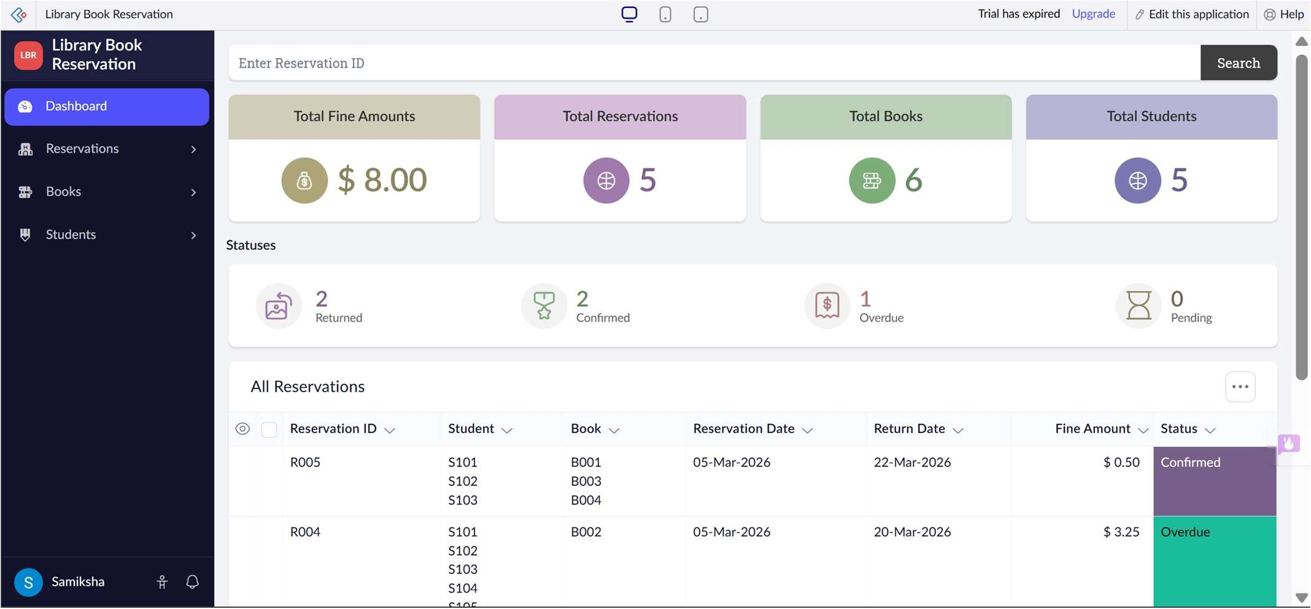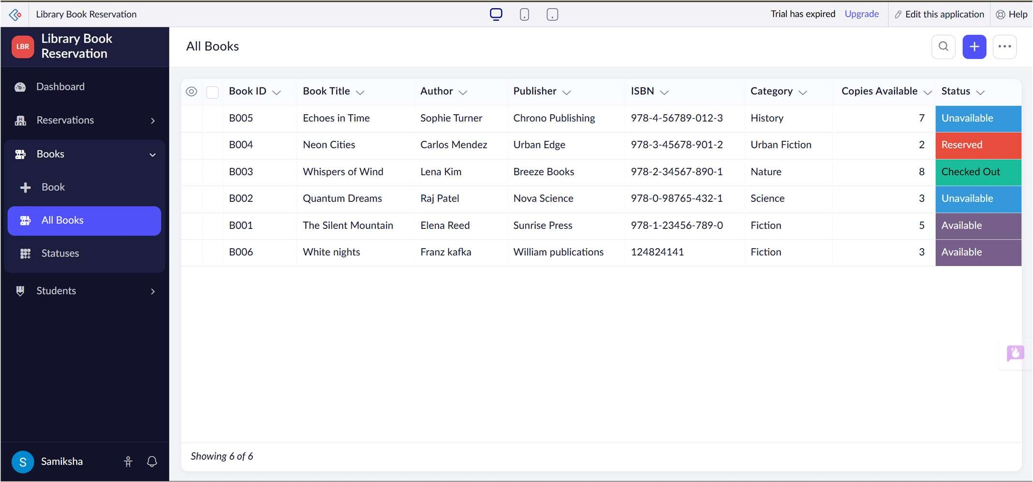
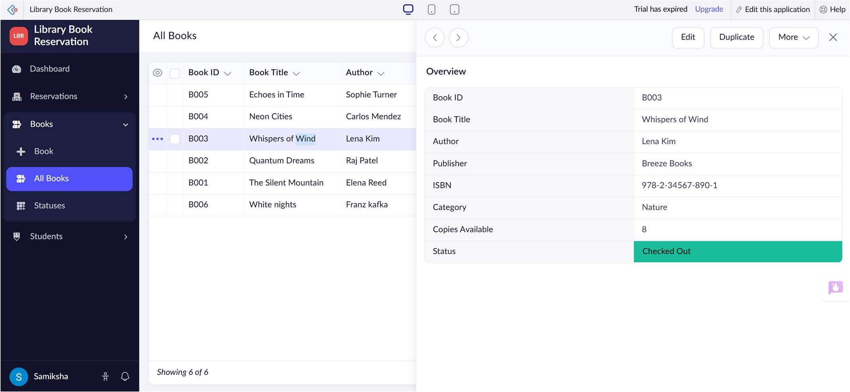
Experiment 2: Create a simple cloud software application for Payroll Processing System using any Cloud Service Provider to demonstrate SaaS include the necessary fields such as Name of the employee, experience in present org , over all experience, basic pay, HRA, DA, TA, net pay, gross pay etc.
Screenshots:
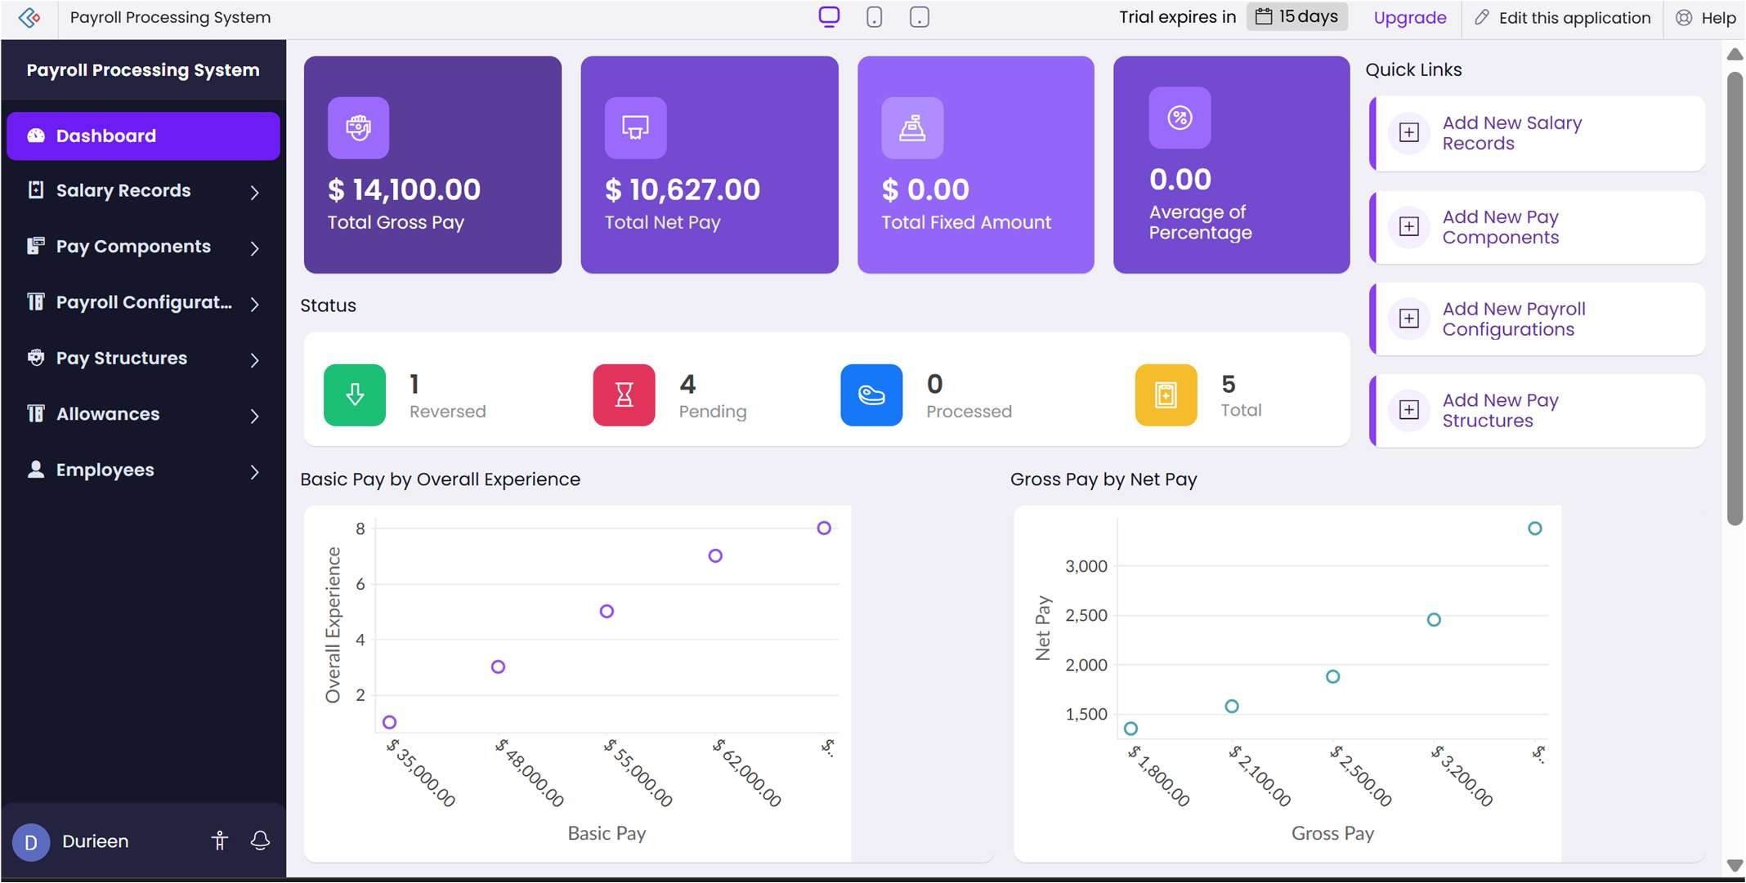
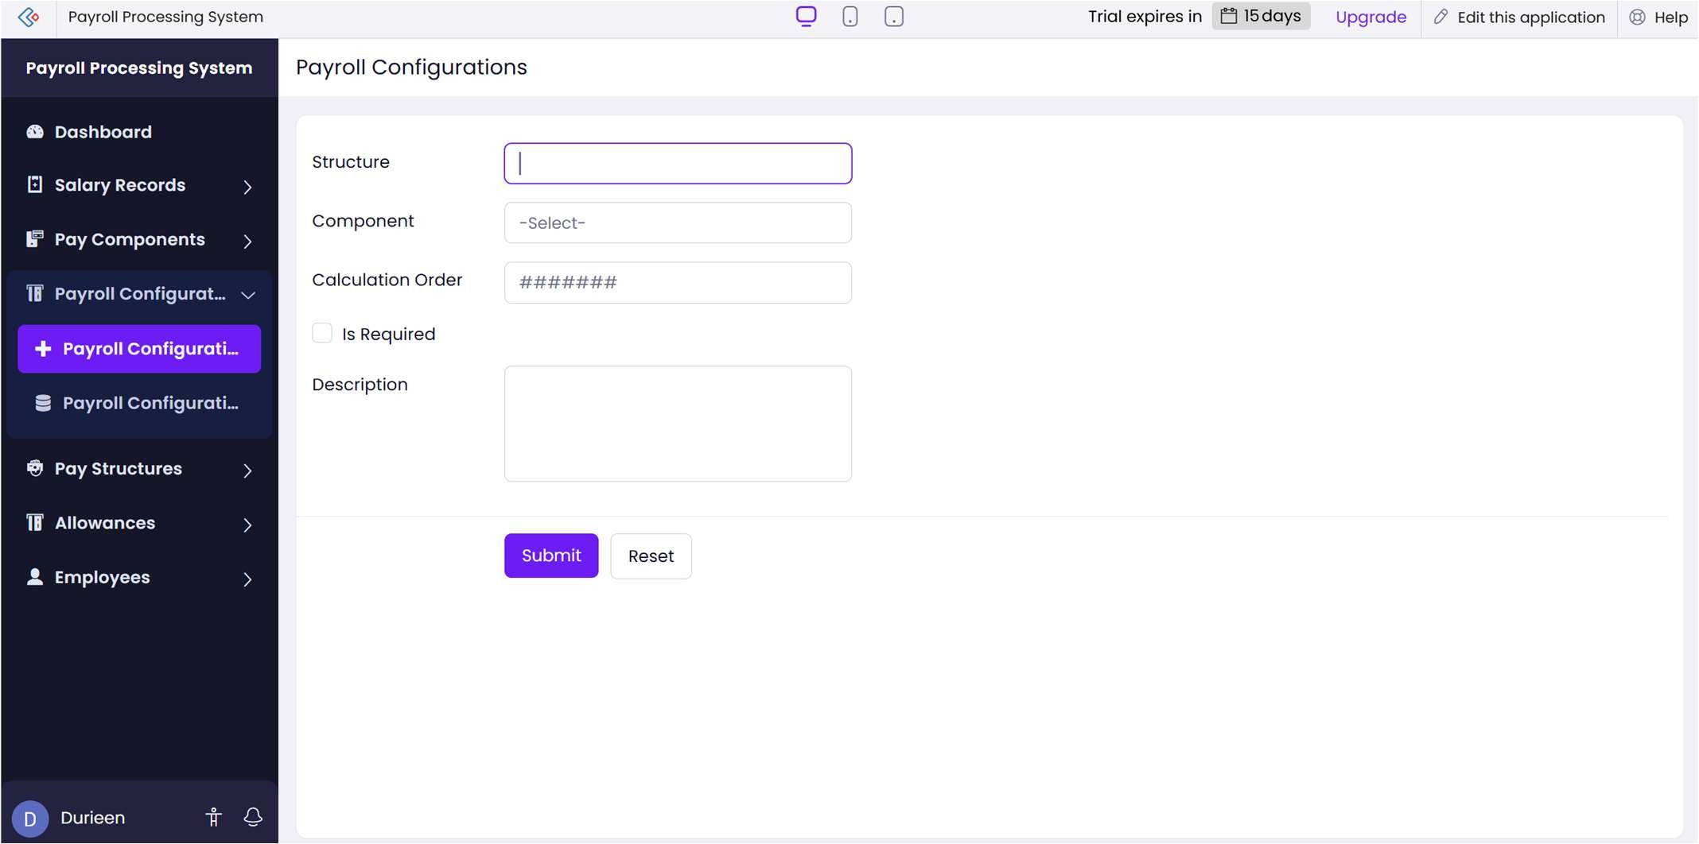
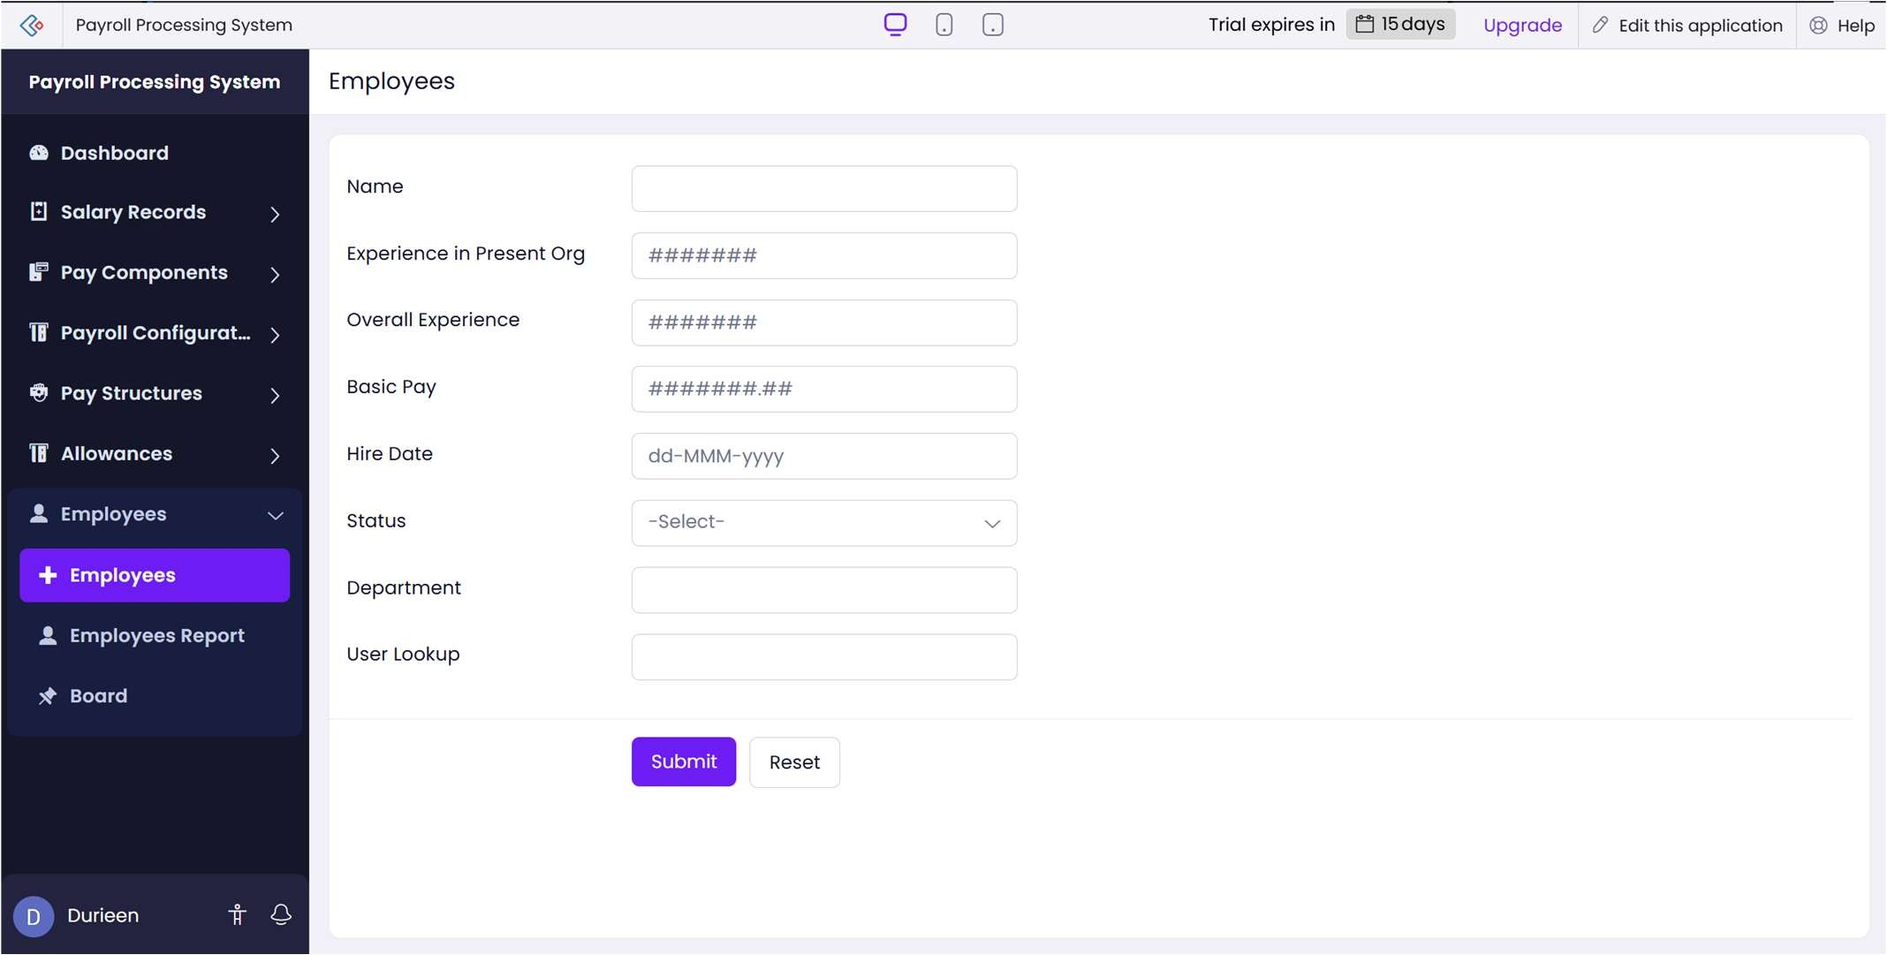
Experiment 3: Demonstrate virtualization by Installing Type-2 Hypervisor in your device, create and configure VM image with a Host Operating system (Either Windows/Linux). Create a Virtual Machine with 1 CPU, 2GB RAM and 15GB storage disk using a Type 2 Virtualization Software.
Screenshots:
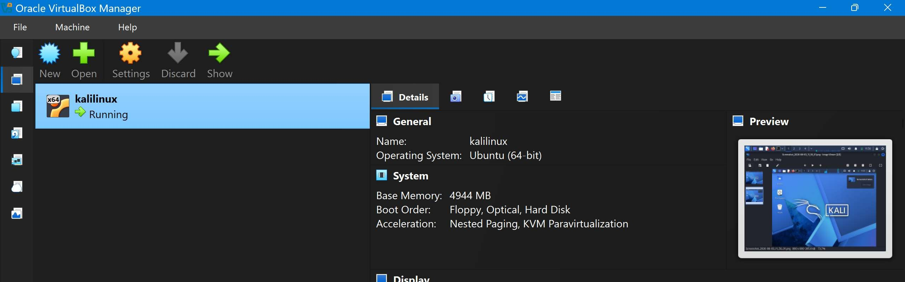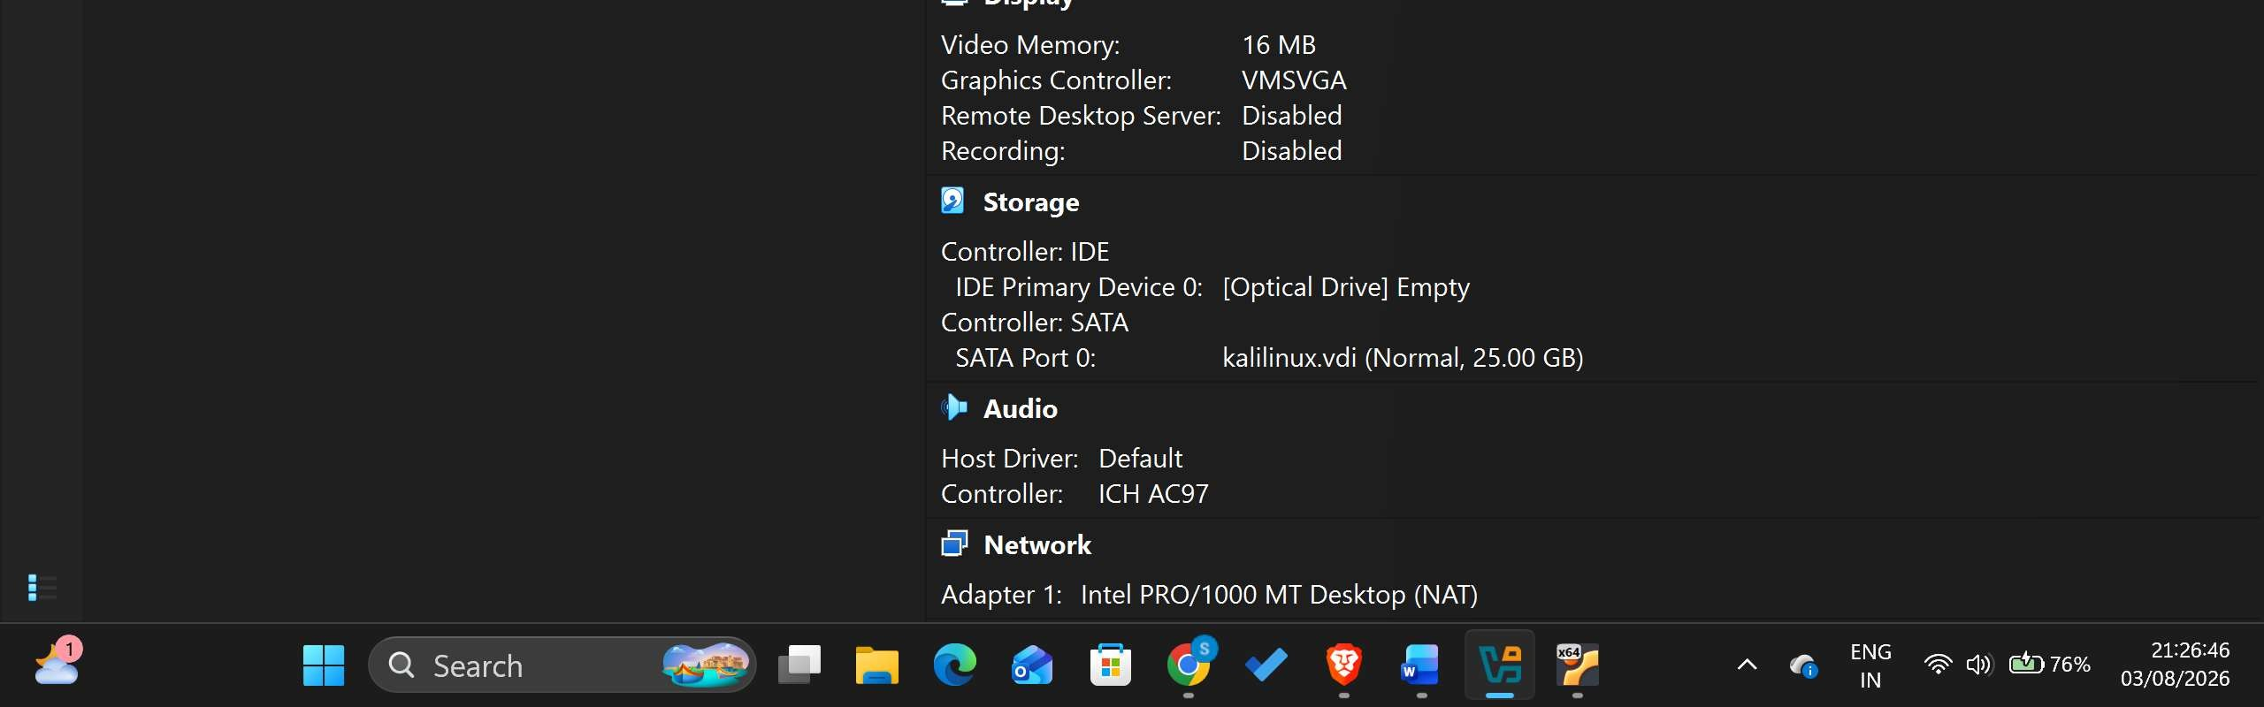
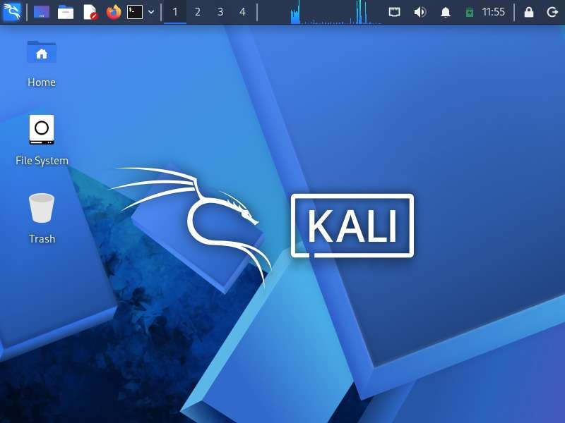
Experiment 4: Demonstrate virtualization by Installing Type-2 Hypervisor in your device, create and configure VM image with a Host Operating system (Either Windows/Linux). Create a Cloning of a VM and Test it by loading the
Previous Version/Cloned VM
Screenshots:
